Amazon Business Intelligence Analysis

Prepared by: Lock Chun Hern
Date: 1 JULY 2025

Table of Contents

1.0 Introduction 2
2.0 Methodology 3
2.1 Datasets 5
2.1.1 Description of the Datasets 7
2.2 Data Preprocessing 8
2.2.1 Data Cleaning 8
2.2.2 Data Transformation 9
2.3 Data Analysis and Visualization 10
2.3.1 Product Performance Dashboard 10
2.3.2 Warehouse Distribution and Logistics Dashboard 11
2.3.3 Financial Health and Forecasting Dashboard 12
2.3.4 Key Competitors Analysis Dashboard 14
2.3.5 Rationale for Customization and Interactivity in the Dashboard 14
3.0 Key Findings 16
4.0 Recommendations for Stakeholders 17
References 19

1.0 Introduction

In this project, Amazon, a global leader in e-commerce, faced inefficiencies in its decision-making process without a structured data-driven approach. Decisions were often delayed due to a lack of reliable and consolidated insights, leading to operational inefficiencies and missed opportunities. Immediate data-driven decision making is needed to enhance product sales, optimise its current and future financial strategy, identify areas for expansion in the warehouse and improve logistic efficiency, and assess its market positioning in the face of increased competition from other online and physical retailers.
The level of decision making is a strategic decision-making level, in which the stakeholders involved are higher management level and focus on long-term decision that aligns with the overall vision and mission of the company. This decision level requires insight mainly on insight for market trends, financial forecasting, business growth, warehouse expansion, and competitive positioning in the market. The stakeholders for the decision level include internal stakeholders like executive leadership (CEO, CFO, COO), head of business department, corporate strategy team and external stakeholders like investors or shareholders.
The executive level is concerned about long-term goals and overall direction of the company, and requires data-driven insight to drive high-level strategic decision-making, including operational and financial strategy of the company. The head of the business department and the corporate strategy team are more concerned about product performance analysis and the positioning of market competitors. The investor and shareholders are interested in the financial performance of the Amazon company, and strategic insight can be obtained from financial analysis and forecast results. They have the power to affect the company's long-term strategy and are more concerned with maximising the profit of company.
Main BI tools used in this project include Python, which is operated in Google Colab, and Microsoft PowerBI on the local machine. The explanation of the tool’s area of usage will be combined with the analysis plan.
The key objectives of the analysis are as follows
1. To investigate the market trends derived from sales of each product category and product reviews to gain insight for adapting the product strategy.
2. To conduct financial analysis based on financial reports: income statement, cash flows and balance sheet of the company for evaluating financial health, followed by forecasting techniques applied to reveal strategic insight for future direction.
3. To investigate the geographic data of Fulfilment By Amazon (FBA) warehouse and inventory management system by the logistic partner to allow strategic expansion of the fulfilment centres and improve supply chain efficiency
4. To assess the competitive threat from direct competitors, specifically Costco and Walmart, by examining their past revenue, marketing spends, and market shares in E-commerce in the United State for the past 10 years.

2.0 Methodology

The analysis involved several steps:
Step 1: Data collection (Python)
The data source required for BI analysis needs to be identified and collected. The data are involved in direct download from the website and web scraping using Python, like Yahoo Finance. It is noted that as the internal data from the company is kept confidential and not provided, most of the data is obtained from external sources.

Step 2: Data Preprocessing (Python + Power BI)
The dataset collected from various sources needs to be cleaned before visualisation and further analysis. This is done by using Python on Google Colab, by importing the dataset collected. The cleaning process is done first using Python, then integrated into a unified dataset. The dataset is then imported into PowerBI for Analysis and Visualisation to be done. Some data required further data cleaning using the Power Query in PowerBI. Power Query also help with data transformation, which is extremely important to generate new features for analysis.

Step 3: Visualisation (Power BI)
Visualisation is done in PowerBI to produce an interactive dashboard, which presents analysis results in bar charts, line charts, cards and other visualisation techniques. Interactive components are to be included, for example slicer and a slider, to enable the user to dig deeper into the data. 5 dashboards are planned for different datasets to address the needs of different stakeholders, which include product analysis dashboard, financial dashboard, forecasting results, warehouse dashboard and competitor analysis dashboard.

Step 4: Forecasting (Power BI)
Forecasting is done by using PowerBI built-in forecasting function on the financial dataset to project future trends. Key performance metrics are chosen for forecasting, like total revenue, total debt and cash flow. These AI forecasting models (ETS) allow financial planning and budgeting to be done based on data-driven decision.

Step 5: Presentation of Key Findings and Conclusion
The last step will involve reporting key findings and conclusions for the data. This will be done through Microsoft Word, where all the steps and insights will be recorded. 3

2.1 Datasets
There are 5 main categories of datasets that are collected for the studies, which are mostly from external sources. These include product reviews, warehouse dataset by logistic partner, stock data, financial reports and market competitor dataset as shown in Table 1.1. These datasets include different data types, for example, quantitative data: price, dividend; categorical data: product categories (nominal), ratings (ordinal), and qualitative data like text data.

Table 1.1: Datasets used in this Project
Dataset | Details | Source
Amazon Product Reviews Datasets:  i) amazon_categories.csv  ii) amazon_products.csv | -Scraped dataset from Sep 2023. Contains pricing & sales data of US products.  -The amazon_products.csv and amazon_categories.csv are linked through a foreign key  i) 7kb, 249 rows, 2 columns  ii) 358 MB, 1.4M rows, 11 columns | (Asaniczka, 2023)
Amazon Warehouse and Logistics Dataset  Amazon FBA Locations 2025 (UPDATED) - Master List [AMZ Prep].xlsx | -Fulfilment by Amazon (FBA) Location list in the US and Canada  -Provided by the Logistic partner of Amazon  -Inventory management tools of logistic partners  -64kb  -3 sheets:  1050 rows, 4 columns  28 rows, 4 columns  121 rows, 3 columns | (Forrest, 2025)
Amazon Stock Data:  AMZN_stock_data.csv | -Historical stock market data for Amazon (AMZN), stocks dataset from 1977 to 2025  -Sourced from Yahoo Finance  -788 kb  -6988 rows, 8 columns | (Ali, 2025)
Financial Datasets:  i) amznincome_stmt.csv  ii) amznbalance_sheet.csv  iii) amzncash_flow.csv  iv) amznquarterly_incomestmt.csv | -Amazon income statement, balance sheet, and cash flow scraped from Yahoo Finance  -Market Data from Yahoo! Finance’s API  -Data period: 2021 to 2025  i) 4kb, 48 rows, 6 columns  ii) 5kb, 62 rows, 6 columns  iii) 5kb, 53 rows, 5 columns  iv) 5kb, 47 rows, 6 columns | (YahooFinance, 2025)
Market Competitors Datasets:  i) Costco_US_Revenue_and_  Marketing_2015_2024.csv  ii) Walmart_Costco_US_Market_  Share_2016_2024.csv  iii) Walmart_US_Revenue_and_  Marketing_2016_2025.csv | -These datasets provide market share and revenue data of competitors of Amazon e-commerce, which are Walmart and Costco  -Data period: 2015 to 2025  i) 1kb, 11rows, 3columns  ii) 1kb, 10 rows, 6olumns  iii) 1kb, 11rows, 3columns | (Khayyum, 2025)

2.1.1 Description of the Datasets
1. Amazon Product Reviews Dataset:
This dataset was web scraped by Asaniczka (2023), which contains product data of US products in Sep 2023. Two CSV files are included in this dataset: amazon_products.csv and amazon_categories.csv, which are linked through a foreign key. It is included as it contains a huge amount of data (1.4M rows), which is enough to provide a comprehensive analysis based on product details, product categories and price. This can uncover hidden market trends for strategic planning.
2. Amazon Warehouse and Logistics Dataset:
This dataset is provided by Amazon Logistics Partner, AMZ Prep, requested from Linkedin. It is included as it provides up-to-date and real-world data for Amazon FBA (Fulfilled by Amazon) warehouse locations and addresses. Fulfilled by Amazon refers to the way that third-party sellers store their products in Amazon's fulfilment centres, and Amazon handles storage, packaging, shipping, and customer service, compared to the traditional way of shipping by sellers after receiving orders. Also, the dataset contains information on the inventory management tools used by the logistics partners. These attributes are suitable for strategic decision making for warehouse relocation or expansion, and evaluation of logistic software by partners.
3. Amazon Stock Data:
This dataset is obtained from Kaggle, which scrapes stock data from Yahoo Finance. It contains Amazon stock data from 1997 to 2025. It includes open, high, low, close, volume, dividends, and stock splits, which are extremely valuable for strategic decision-making level because they reflect the investor sentiment and market confidence level. The insights derived from this data can help respond to key stakeholders' (executive, shareholders) interests.
4. Financial Datasets:
This dataset is sourced from Yahoo Finance by web scraping on a local pc. It contains financial reports of Amazon, including the income statement, the quarterly income statement, the balance sheet, and the cash flow from 2021 to 2025. This includes revenues, debt, cash and many detailed financial data for trend analysis and strategy planning for overall financial health.
5. Market Competitor Datasets:
These datasets provide a comprehensive overview of Walmart and Costco in the United States, covering the period from 2015 to 2025. It is uploaded by Khayyum (2025) to Kaggle. Walmart and Costco are direct competitor of Amazon as they are physical retail business which overlaps with most of their products (groceries, electronic products, clothing) with Amazon, and they are starting to grow their business in E-commerce as well. There are 3 individual datasets from the source which will be merged into one. The dataset contains attributes like revenue, market share, retail market size and marketing spending data for the competitors.

2.2 Data Preprocessing

2.2.1 Data Cleaning
Data cleaning is carried out by using Python through Google Colab. The missing values are checked and removed if they are less than 5% of the total rows. Since all the datasets have null values of less than 5%, the data loss is negligible compared to the whole dataset, and they are all removed. Duplicates are checked and all removed. These steps are carried out to ensure data integrity for further analysis and machine learning algorithms, which ensure accuracy in the data and prevent errors. Imputation is not done as it may cause noise in the data.
For the Amazon FBA dataset, the ‘Type’ column, which refers to the type of warehouse, in both the US and Canada datasets has have high proportion of missing values (around 30 to 40%), and its entries are inconsistent. The type column is dropped for the datasets despite potentially having some useful information, as there is too much noise and sparsity, which will reduce the reliability of the analysis.
An exception is made for the Amazon Market Datasets, which contain financial reports for Amazon. In the income statement and balance sheet CSV, the 2020 column contains all null values, so the entire column is removed. However, the other null values in between the datasets are not removed. This is because financial statements are interconnected, and removing the rows with missing values might affect the balance of the accounting sheets and break ratios and trends. It might also affect the continuity of time series data. Also, since the years are listed across the column initially, the structure of the financial datasets is fixed by transposing the rows to columns, to make all the years in one column and other rows like revenue as columns. The first row is promoted to a header, and the index is reset to make the year a column.
Data types like integer, datetime and float are checked in Python and corrected by using Python and PowerBI (auto-transformation when loading). Most of the datasets have their date and time incorrectly set as object (string) after checking info, therefore conversion is needed by using pd.to_datetime() commands. This can ensure the columns correctly identify the column and DateTime and prevent errors in downstream analysis. When loaded to PowerBI, the datetime columns are treated as numerical, which displays the datetime inaccurately despite being correctly set in Python, so each datetime column datatype is converted back to Date/Time manually in PowerBI.
For the FBA Warehouse location dataset, the first row is not set as a header initially in PowerBI. Power Query is used to set the first row as a header. Also, the data type for the columns in FBA warehouse location dataset are set manually in PowerBI and renamed to State and Address accordingly.

2.2.2 Data Transformation
In the product reviews dataset, although the actual sales quantity is not available, “bought in last month” column is used as a recent sales volume proxy. Data transformation is done to add new features for analysis. These transformed features aid in promotional strategies and pricing analysis.
a) “Simplified categories” column is created for product reviews based on the 248 categories, which have a lot of overlapping, for example, women's clothing, women's shoes, women's jewellery and men's shoes grouped into one group of clothing and jewellery. The grouping is done manually in PowerBI by right-clicking on the column name to create a new group, and the simplified categories now have 14 groups, which are easier to analyse.
b) “Discount Percentage” is calculated by subtracting the price from the list price, then dividing by the list price. If one of the columns (original price or actual price) is blank or shows 0, then the discount percentage is not calculated.
c) “Price Bucket” is defined by using <50$ = low, 50-300$ as mid and >300$ as high to segment the products. These are made with the assumption that the price tier is universal and not category-specific.
d) “Estimated Sales” column is calculated by multiplying “bought in last month” column by the price. COALESCE function is included in the DAX code, which uses the “list price” (original price) if the “price” (actual/discounted price) column is blank, so that the sales can be calculated correctly.
For the Inventory Management Tool dataset, the inventory tools are grouped into categories by using DAX code to find strings with inventory, shipping, sourcing and accounting and categorise them accordingly. This step is crucial to review the logistics software used by the partner, as without grouping, there are more than 100 distinct software which are hard to analyse.
The finance dataset and stocks dataset do not require many data transformations. Only Year-over-year revenue growth is calculated by using DAX code to use for the KPI card. The market competitor dataset also did not require data transformation in this project.

2.3 Data Analysis and Visualization
The storyboard will start with a dashboard with insight derived from product reviews and analysis on sales and demand of different product categories to support strategic planning. This will uncover the customers’ preferences and the market trends, which allows decision-making on the product categories to focus on to increase revenues. Then, the story continues with the warehouse and logistics aspect of Amazon e-commerce, to discover opportunities for improved operational efficiency and market expansion.
Next, a financial dashboard presenting Amazon’s past annual and quarterly financial performance is shown, including stock price movement that reflects market sentiment. This is followed dashboard presenting revenues and debt forecasting. This analysis reviews the financial health of the company and helps to budget future expenses. Lastly, the competitor’s market data, focusing on Walmart and Costco, is analysed and presented to draw strategic insights for Amazon’s competitive positioning in the e-commerce market.
Dashboards are created as shown in figure below by using Microsoft PowerBI.

2.3.1 Product Performance Dashboard

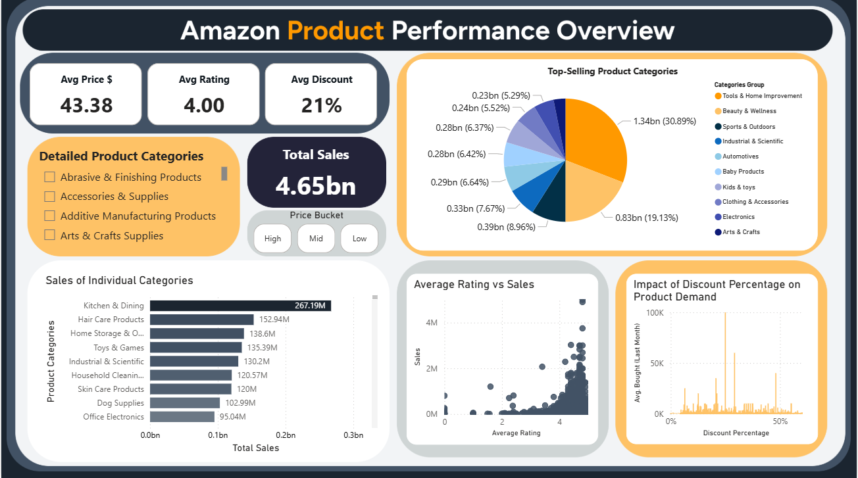Dashboard 1: Amazon Product Performance Overview
The first insight to extract is: “what are the top selling grouped categories and individual categories?”, which will be presented in a pie chart and a bar chart, respectively. The relationship between ratings and sales will be investigated are plotted on a scatter plot. Also, insight regarding the best range of discount percentage to increase the product sales count is to be extracted through a bar chart. Combined with the charts above, to get the insight of which price group has the best sales, a price bucket slicer is added. A bar chart is selected for most cases as it is easy to understand and compare for a large number of distinct groups. Pie chart performs visually well to show the proportion of sales of each category, but because it can only include a small number of variables before it clutters, only grouped categories are plotted in this way. Also, cards are added to show the total sales, average price, average ratings and average discount of the data. These visualisation techniques help to extract the insight regarding market trends and customers' preferences for optimal marketing and pricing strategies.

2.3.2 Warehouse Distribution and Logistics Dashboard

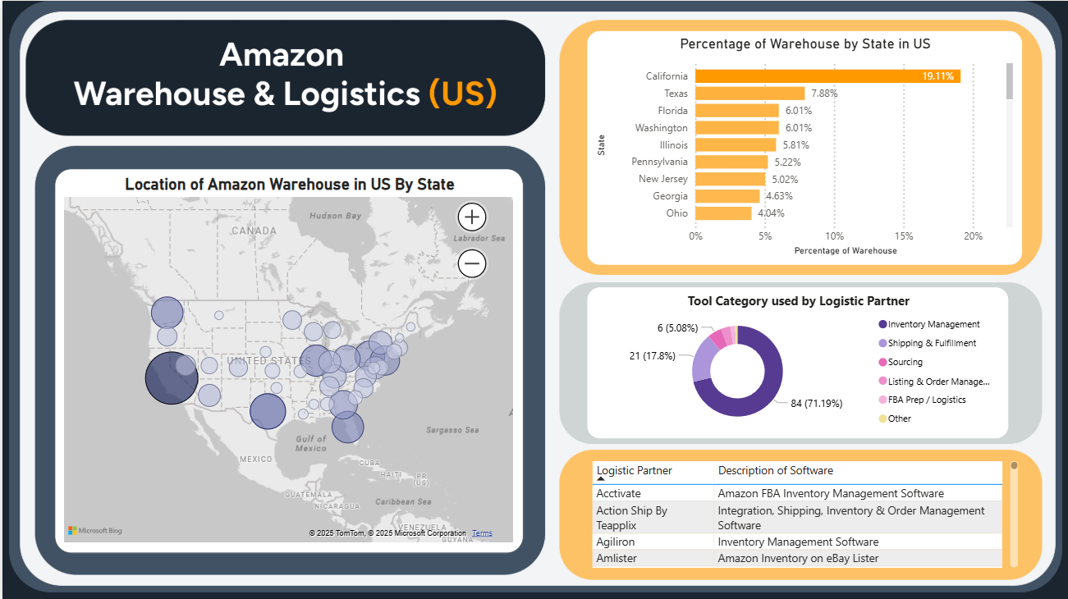Dashboard 2: Amazon Warehouse and Logistics in United States
The insights planned to get from this dataset include the warehouse distribution and determining the gaps for strategic expansion. This is done by using a bubble map. This visualisation shows the warehouse number corresponding to bubble size, which is effective in determining the concentrated region and gaps. A bar chart is plotted to show the proportion of each warehouse in each region, which provides additional information for the map visualisation. Another insight to get includes the software that is currently used by the logistics partner, which is grouped in a pie chart, with the detailed names of the software shown in the table.

2.3.3 Financial Health and Forecasting Dashboard
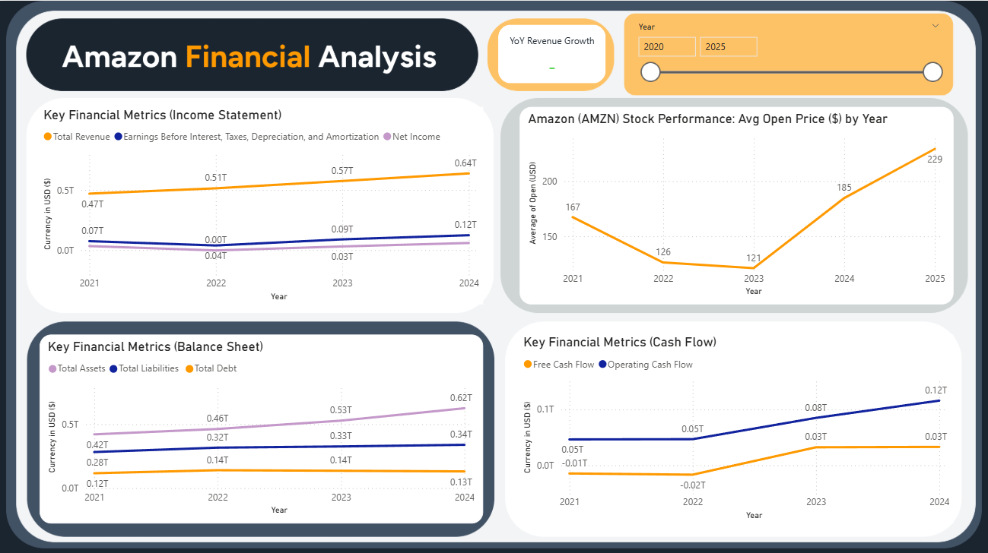Dashboard 3: Amazon Financial Analysis
The insights to extract from the financial dataset are the current and future trends of the financial performance of Amazon to support long-term planning. A line chart is used for all the financial metrics, as it works best for time-series data with time (date/ year) plotted on the x-axis, presenting the trends and seasonality effectively. Also, Forecasting can be done with PowerBI built-in prediction function, which works on a line chart. Also, a KPI card is included to highlight the Year-over-Year growth for total revenues, providing additional insight into the growth of revenues.
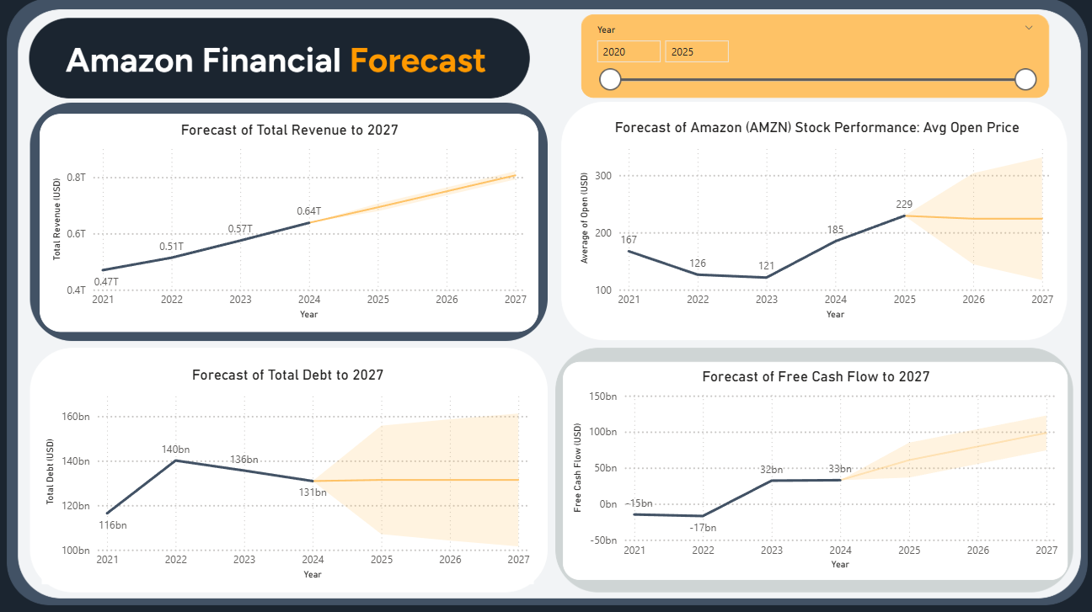Dashboard 4: Amazon Financial Metrics and Stock Performance Forecast
The forecast method built into Power BI is powered by Exponential Smoothing (ETS), which accounts for error, trend and seasonality in the time series data. ETS also gives more weight to recent values. It is effective in predicting short-term values and produces a 95% confidence interval (area in lighter orange surrounding the forecast line) to aid in interpretation. Notably, ETS assumes stability and consistency in the time series data, which makes it suitable in this case for seasonal and trend-following metrics like total revenues, free cash flow and total debt visualised in the dashboard. The model also generates a 95% confidence interval to aid in interpretation, which is more helpful than just a single predicted value for each year.
Predictive analysis is an extremely important aspect in financial dashboards, as it provides insight into potential future outcomes. In this case, the use of ETS to forecast revenue growth and debt guides data-driven decisions on Amazon’s strategic allocation of resources, marketing strategy and expenses. It supports the areas which are currently lacking in the company, as mentioned in the beginning. This allows Amazon’s executives to take proactive measures or adjust strategic policies to mitigate potential risk and undesirable outcomes, for instance, negative growth in revenue or a surge in total debt. However, as the stock market is extremely volatile and affected by a multitude of external factors, ETS accuracy is limited for stock data and should not be relied upon for making trading or investment decisions. In this project, ETS is applied to the AMZN average stock opening for general indication of market trends and investor sentiment only.

2.3.4 Key Competitors Analysis Dashboard
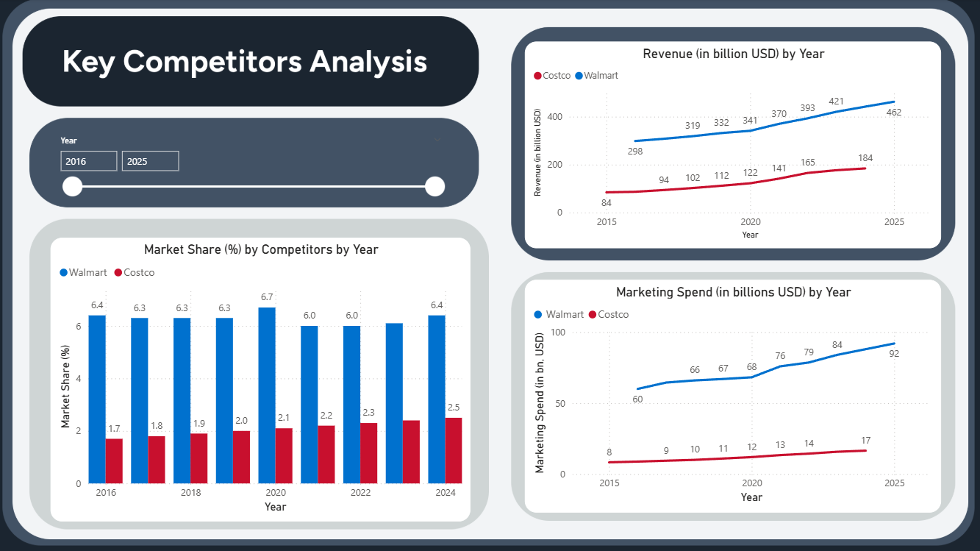Dashboard 5: Key Competitors Analysis
Lastly, market competitors’ performance and competitive positioning in the market are the insights to get from the dataset. Bar charts and line charts are used to plot the market share and revenue of the competitors, side by side to show the trends.

2.3.5 Rationale for Customization and Interactivity in the Dashboard
In the product review dashboard, a detailed product categories slicer is included, for the user to inspect the information of 284 product categories after getting an overview with the analysis on the simplified categories. All of the cards, bar chart, scatter plot and area chart change according to the selection in the slicer to reveal details about that particular category. There is also a price bucket button slicer introduced so the user can pick the price bucket for further investigation. The bar chart of the sales of individual categories can be scrolled down to show sales of more categories. Also, the pie chart can be clicked to show focus on details about the 14 grouped product categories.
In the Warehouse and Logistics dashboard, the bubble map can be focused by pressing the button (focus node) on the top right. The count of warehouses in each state can be viewed by hovering over the circle in the map. Zoom button is turned on so the viewer can easily zoom in and out. The bar chart can be scrolled down for states that have a smaller percentage of warehouses. By clicking on the bar, it can zoom into the exact location of the responding state on the map. Different tool category groups in the pie chart can be selected as well to change the table below into the category of interest.
For the financial analysis and forecast dashboard, a slider to filter the time period in between is introduced at the top right corner. This allows users to customise and zoom in on the specific period of interest, down to the exact date level. User can also pinpoint their pointer on the line chart to obtain data about the specific time point. Similar approach is done for the market competitors’ dashboard, because it contains time-series data like revenues, market share per year, which are similar to the financial analysis dashboard.

3.0 Key Findings
Product performance analysis of 1.4 million different products reveals that Tools and Home Improvements has the highest sales in the last month, accounting for $1.34 billion (30.89%) of the total sales, followed by Beauty and Wellness at $0.83 billion (19.13%). As for individual categories, kitchen and dining have the highest sales of $267.19 million, followed by hair care products at $152 million and home storage and organisation, which accounted for $135 million. These individual product categories resonate with the results from grouped categories. Looking at different price buckets, it is shown that the total sales are $4.65billion and the items at the “Low” price bucket, which is below 50$, have the most sales out of the three, accounting for $ 3.31 billion. The scatterplot of average rating vs sales reveals that most sales occurred for items above 4 stars, and the highest sales item is rated at 4.8. The analysis of the impact of discount percentage and product demand shows that discount percentages of 25% and 29% have the highest average numbers bought in the last month. The insight gained is that the top-selling category groups and low-price items should be the focus of the company for marketing decisions in future, as they accounted for most of the sales. Also, items above 4 stars should be given priority, and the discount percentage can be set between 25% to 29% to get the best-selling counts.
From FBA warehouse and logistic analysis, the warehouse of Amazon in the United States is heavily concentrated in a few states, reflecting a strategic decision based on population density, tax incentives, and proximity to ports. California has the highest number of warehouses, accounting for 19% of the total (194 centres), mainly due to California having the densest population in the US (around 39 million), as well as its proximity to port access points like the Port of Los Angeles and Long Beach. This is followed by Texas (7.88%, 80), and Florida (6.01%, 61), both are in the list of top 3 in population density. In the bubble map, it is shown that Amazon has less presence in the North. Idaho could be the next station for expansion as it may serve as a secondary logistics site in case of disaster on the West Coast (Washington and Oregon). Iowa and Arkansas can be considered as well, considering both are moderately populated, but no presence of Amazon on the map. These insights obtained from the map are helpful for the strategic expansion of the warehouse. As for the management tools used by the logistics partner, each company use different software as shown in the table, which may cause operational inconsistency. This also reduces Amazon's control over key functions such as operational efficiency and customer experience, while also increasing risks related to data security.
For the financial analysis, the financial health of Amazon is at a healthy level, with growing total revenue, net income and an increased cash flow over the past 4 years (2021 to 2024). The total assets of the company are growing while the total debt is declining. The Financial Forecast dashboard shows a high precision, continuous year-over-year growth of 8% in the total revenue of Amazon for the next three years, and growth in free cash flow to $98 billion in 2027. The prediction result of total debt is constant at approximately $131 billion with high uncertainty, indicating possible fluctuations. It is predicted that the stock price of Amazon will drop slightly to $221 with a wide confidence interval, indicating a space for potential growth while highlighting the risk of a significant market shift. With these forecasted insights, strategic financial planning is prompted to utilise the anticipated revenue gains and increased liquidity to grow the business further, identifying key areas for long-term investment and not undermining risk management.
From the key competitors’ analysis, it shows that Walmart, which holds the second largest market share in e-commerce (first being Amazon), has maintained its market share at around 6% for the past 5 years. Cotsco, which is one of the fastest growing competitors in the market, transitioning from a physical retail business like Walmart, has its market share growing from 1.7% to 2.5% over the past 5 years. Considering Amazon has around a 40% market share in e-commerce, the growth rate of these 2 rivals is not expected to cause a significant threat. Significant efforts can be seen from these 2 rivals in terms of increasing marketing spend ($ 92 billion in 2025 for Walmart, $17 billion for Cotsco), which prompts further research into the competitors’ marketing strategy in future.

4.0 Recommendations for Stakeholders
From the analysis, there are several actionable recommendations for the stakeholders:
1. Focus Marketing and Inventory on Top Selling Products
From the insight gained, there are several top-selling product categories, identified and presented by the PowerBI dashboard. These product categories, for example, Tools & Home Improvement, Beauty & Wellness and low-priced items (under $50), are driving most of the sales. The recommendation is to focus on long-term marketing strategy and inventory allocation in these top-selling categories. Promotion can be held with a discount in the range of 25-29% as it is shown to boost the purchase rate in the dashboard. Also, the customers’ reviews can be monitored to identify the products for prioritisation, as highly rated products above 4 stars are more likely to be sold. The BI dashboard developed can track and present the product categories' performance, and can be used monthly and yearly to track the latest market trends for adjusting the company's strategy. These insights are especially useful for the head of business and other executives.
2. Expansion of Warehouse and Development of Standardized Logistic tools
Currently, Amazon warehouses are heavily concentrated in California, Texas and Florida, which are highly populated. Other states can be considered for strategic expansion, to expand the market in a moderately populated region for new markets and serve as a backup for disasters. Currently, Idaho, Iowa and Arkansas have not seen any presence of FBA centres as shown in the PowerBI map, and warehouses can be expanded to these states to close the gaps. Also, the insight obtained from the analysis of the logistic partner’s software prompts stakeholders, like the CTO (Chief Technology Officer), to plan for developing an integrated and standardised software for its logistic partner to enhance overall supply chain efficiency.
3. Development of Finance Strategy from Forecasting Results
From the key findings above, the current financial health of Amazon is great, and future aspects of financial conditions are forecasted to be stable in terms of growth in revenue and cash flows. For the stakeholder (CEO, CFO, shareholders), strategic investment can be planned early to utilise the predicted increase in revenues and cash flow, to support expansion, research and development. However, the forecast also shows that fluctuations in debt level are highly possible; therefore, risk management needs to be done. This means some of the cash flow may be required to reduce the debt load, and the threshold should be set to keep the debt at a healthy level. Overall, these data-driven decisions can be made based on the insight generated from PowerBI, and it can be extended to simulate a What-if situation by forecasting the impact of different investments and allocations of expenses.
4. Continual Monitoring of Competitors’ Market Share and Marketing Strategy
Walmart has been the second-largest player in the market, but its market share has been stagnant in growth for the past 5 years. In comparison, Cotsco, a new player in the e-commerce market, has been observed to make significant growth in market share. While they are not proven to be a significant threat by the information provided, the fast-growing pace of Costco should be monitored yearly for Amazon to maintain its position in the market. Considering both companies have increased their marketing share by 1.5 to 2-fold in the past 10 years, further investigation into the competitors’ marketing strategy is necessary.

References

Ali, M. S. (2025). Amazon Stocks 2025 [Data set]. Kaggle. https://www.kaggle.com/datasets/meharshanali/amazon-stocks-2025
Asaniczka. (2023). Amazon Products Dataset 2023 (1.4M Products) [Data set]. Kaggle. https://www.kaggle.com/datasets/asaniczka/amazon-products-dataset-2023-1-4m-products
Forrest, B. (2025). Every Amazon warehouse location in one database. [DataSet]. LinkedIn. Retrieved June 4, 2025 from https://www.linkedin.com/posts/blairforrest_every-amazon-warehouse-location-in-one-database-activity-7331393454024884226-Iqhu/
Khayyum, A. K. (2023). Walmart and Costco revenue, marketing and market share [Dataset]. Kaggle. https://www.kaggle.com/datasets/abdulkkhayyum519/walmart-and-costco-revenue-marketing-and-market-share
Laxman, D. (2024). Amazon Reviews Dataset.[Data set]. Kaggle. https://www.kaggle.com/datasets/dongrelaxman/amazon-reviews-dataset
YahooFinance. (2025). Amazon.com, Inc. (AMZN) Financials. [Data set]. Retrieved June 1, 2025, from https://finance.yahoo.com/quote/AMZN/financials/

